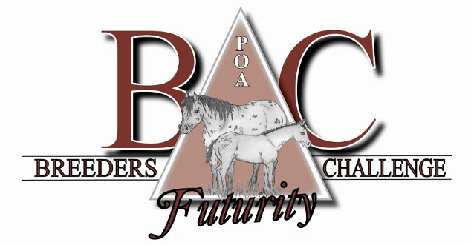

Call to Order – Jackie Guthrie at 3:05pm

Roll Call: Directors Jackie Guthrie, Jackie Hall, CA Good, Lori Krome, Corey Damman, Jess Drish, and Director candidate, Brad Wilson. Director Orlen Stolee arrived later.

**Reports:**

1. Secretary’s/Treasurer’s Report from Cristy Gutierres:
   1. $2,995.26 in checking
   2. $7,279.53 in savings
   3. $700 from Stalling
   4. $2,000 from raffle of computer
      1. Entertain offering this raffle again this year. Possibly for an i-pad this year instead.
   5. $7,000 from Stallion services last year
   6. $1,000 from services sold, then backed out of
2. President’s Report:
   1. Thank you’s to all involved/Recognition
   2. BCF Show will be Tuesday, October 4th
      1. Adult style format similar to Intl. format
      2. Josie Baxter is hiring judges and working on awards

**Old Business:**

1. Premier Sire Award
   1. Proposed by Tammy Virzi (she’ll sponsor), looking for additional sponsors
   2. Point tally of all BCF offspring by each sire throughout the show.
      1. Including the following classes: weanling classes, yearling lounge line, yearling in-hand trail, 2 y/o HUS, and 2y/o WP.
   3. Tammy is willing to help coordinate the point system and tabulate the points.
   4. Motion to accept the Premier sire award by Jackie Hall. Seconded by CA Good. Unanimous.
2. Incorporation Papers
   1. Still looking for these papers to have the documentation. Jackie will contact Deidre Schroeder in Rudd, Iowa. Brad Wilson offered to help with this.
3. Recap of the 2015 BCF Show
   1. 51 stalls $760
4. Laptop Fundraiser
   1. Motion by Jackie Hall to purchase an i-pad mini 4 16GB for the raffle this year. Seconded by Corey Damman. Unanimous.
   2. $5/each and 5 for $20
   3. Thanked Orlen for his efforts on the 2015 Computer Raffle.
5. Website
   1. $250 to start-up, $10/hour to manage
   2. Mission statement needs to be added. Jackie will work on this.
   3. Archives of all show results from 2008 to the present not on the website yet. It is a work in progress.
6. Accepting Credit Cards
   1. 3% fee on all CC payments taken.
7. Other:

**New Business:**

1. 2016 BCF Show
   1. Showbill will be an adult format with w/t and w/t/l; 39 & over classes, etc.
   2. Judges, Announcer, Ring Stewards (scribes), Stalling, Bedding, Gate people, Trail course design & set-up.
   3. Charlie Phillips will announce. Josie Baxter is working on judges and the rest.
   4. Program Printing & Advertising
      1. Would we like to entertain putting out a program for the show.
      2. Discussion:
         1. Auction off the cover, back cover, inside cover, inside back cover, and center spread in color.
         2. Must be submitted by August 1to Tammy Virzi.
      3. Motion by CA Good to have a show program for this year. Second by Jackie Hall. Unanimous.
   5. Awards & Sponsorships: Weanling Classes will get belt buckles again. Other awards for the LL, IH Trail, HUS, and WP. Josie B. and Jackie H. will work on this.
2. Intl Futurity Sponsorship
   * 1. Motion by Jackie Hall to purchase an advertisement page in the Futurity program book, as well as one page in the June issue of POA Magazine.
     2. Will extend the entry deadline to July 31for the Yearling and 2 YO classes.
3. New Director Nomination
   1. Brad Wilson was approved as a BCF Director.
4. Site of the 2017 BCF Auction TBD. We will look into alternate sites in Ames.
5. Need Mission Statement for Website. Jackie G. will work on.
6. Monetary Refund to Directors when they leave the Board. (Larry Myers explained via phone, after the meeting, that the original Directors had all been refunded $150 the following year, and the other $100 went towards the Mason City, Iowa dinners and for Entertainment at the Intl. Sale when it moved to Des Moines.)
7. Secretary/Treasurer Position. Talked about splitting the positions. No action. Cristy G. is getting more help this year, and would like to continue in her role.
8. Jackie H. made centerpieces for the tables and will raffle these off. Also will do a 50/50 raffle. Kelly Phillips is in charge of the White Elephant Auction tonight. Have reservations for 45+ dinners.

Date of the Next Meeting: June 3rd or 4th – at Midwest Regional in Cedar Rapids, Iowa.

Adjournment:

Motion to adjourn by CA Good, seconded by Lori Krome. Unanimous.